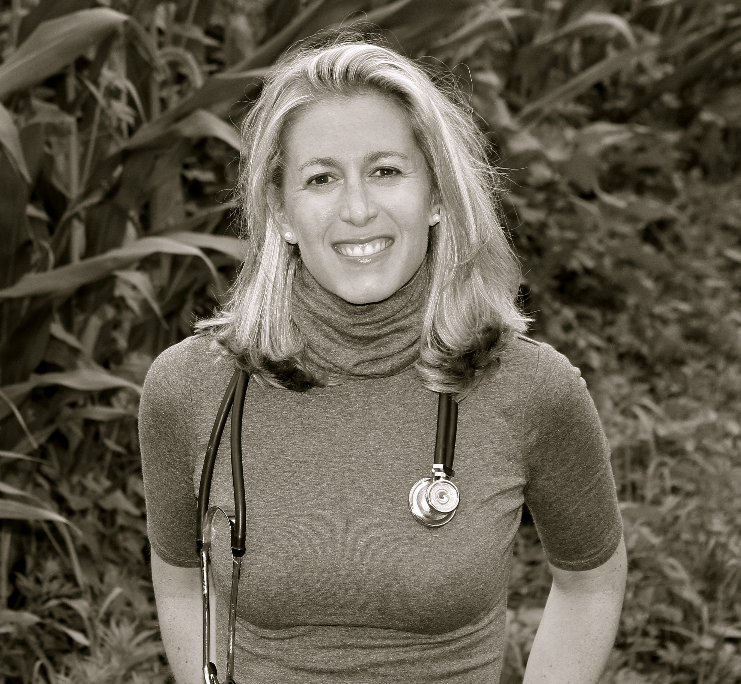

Aly Cohen, MD, FACR, FABOIM AlyCohenMD.com
TheSmartHuman.com

Dr. Aly Cohen is a board certified rheumatologist, integrative medicine specialist, and environmental health expert specializing in arthritis, immune system disorders and women’s health.

Dr. Cohen received her undergraduate degree at the University of Pennsylvania. She went on to medical training at Hahnemann University Hospital School of Medicine in Philadelphia, and completed her internship and residency in internal medicine at Beth Israel Medical Center in New York City. Dr. Cohen continued her specialist training in rheumatology and autoimmune diseases at Montefiore Hospital/Albert Einstein University Hospital in the Bronx, New York. Dr. Cohen is currently in private practice in Princeton, New Jersey. Her practice, that she founded in 2011, Integrative Rheumatology Associates P.C., focuses on both traditional western medical management of rheumatologic ailments, as well as integrative options for total “wellness”, such as biofeedback, acupuncture, cognitive therapy, diet and exercise counseling, environmental toxin counseling, smoking cessation, stress management and sleep evaluations.

Dr. Cohen is trained in medical acupuncture from the Helms Institute at UCLA and Environmental Medicine from Dr. Andrew Weil and the Arizona Center for Integrative Medicine. In 2012, she was honored as the recipient of the Jones/Lovell Rheumatology Scholarship at the Center for Integrative Medicine in Tucson, Arizona. She has studied and worked alongside Dr. Andrew Weil and his colleagues in the field of integrative medicine over the past two years. Dr. Cohen regularly lectures on healthy dietary and integrative medicine techniques to her patients and the community.

Dr. Cohen’s strong interest and work in the area of environmental chemical exposure and health lead her to a collaboration with the Environmental Working Group (EWG.org) to create a CME accredited presentation on endocrine disrupting chemicals and their relationship to human health, designed specifically for physicians, nurses and other health professionals. She lectures nationally on this topic to communities, academic institutions and medical schools. She has been a consultant for major corporations such as Knowledge Universe to help reduce the chemical exposure of infants and toddlers in over 2,000 KinderCare Daycares across the United States. Currently, she is working as a medical investigator in the Paulsboro, New Jersey train derailment in 2012 that spilled thousands of gallons of polyvinyl chloride. In addition to the education of adults on this topic, Dr. Cohen has extended her message to the education of young people. She is currently piloting a program at Princeton High School to integrate environmental health information into the current health curriculum. She was chosen to present for TEDx Cape May in 2019, entitled “How To Protect Your Kids from Toxic Chemicals”.

Dr. Cohen was honored to speak at NAEYC’s 2014 National Institute for Early Childhood Professional Development. She completed co-editing/authoring the “Integrative Environmental Medicine” text, for the Weil/Oxford University Press academic book series, which was published in 2017. Her consumer text with Oxford University Press, “Non-Toxic: Living Healthy in a Chemical World”, will be released in 2020. She was awarded the 2015 New Jersey Healthcare Heroes Award for Education, voted Top Docs NJ every year from 2016-2021 by her medical colleagues, voted Top Doc Suburban Life Magazine 2017, voted America’s Top Doctors and Top Women in Medicine by Castle Connolly, Top Doc 2021 for Philadelphia Magazine and New York Magazine, and was honored with the 2016 Burton L. Eichler Humanitarian Award for her work in environmental health education and curriculum.

In 2012, Dr. Cohen created The Smart Human LLC. (TheSmartHuman.com), to educate colleagues and the community on the potential health issues from exposure to everyday chemicals. She performs in-home chemical evaluations (“chemical-proofing”), lectures to schools and camps, consults with corporations and is a legal medical export for chemical exposure cases. She has partnered with a recognized educator to create tailored environmental health and wellness curricula for schools nationally. She is currently on faculty and writing environmental health curriculum for the Academy of Integrative Health and Medicine (AIHM). She has a very active social media platform, TheSmartHuman.com, Facebook: The Smart Human, and Twitter/Instagram: @TheSmartHuman, and posts practical tips and health information regularly at TheSmartHuman.com and runs The Smart Human podcast.

Dr. Cohen is a regular health contributor to radio and news broadcasts, such as Fox 5 NY, and lectures nationally and internationally on various health topics including integrative medicine, autoimmune disease/inflammation, health effects of everyday chemicals and cell phone safety. She works as a writer for TLC.com, EverydayHealth.com, WebMD.com, and Women’s Running Magazine. She is an interviewer and producer for children and adult health programs on an array of network and cable TV channels. She is also a published medical author. Dr. Cohen was recently asked by actress Fran Drescher to join the medical advisory board for “Cancer Schmancer”, her cancer prevention foundation, and Dr. Cohen was keynote speaker at the 3rd Annual Cancer Schmancer Health Summit in 2017. She was a featured speaker at the 2018 Nutrition & Health Conference, with Dr. Andrew Weil and colleagues, and presented at the 2018 American Psychiatric Association’s national meeting on environmental exposures and their effects on mental illness. Most recently, she presented, “Integrative Rheumatology: Western and Eastern Approaches for Rheumatologic Illness”, in Cape Town South Africa and continues to lecture on the holistic prevention and management of variety of autoimmune diseases. She lectured with Dr. Deepak Chopra and colleagues in 2019 at the annual Academy of Integrative Health and Wellness (AIHM) in San Diego. In June 2020, she was a featured speaker on the connection between environmental chemicals and response to COVID infection for the Collaborative for Health and the Environment (CHE).

Dr. Cohen is an avid runner, participates in area triathlons and ran in the 2009 New York City Marathon, raising thousands of dollars for The Lupus Foundation. She lives with her husband, two young sons, and several happy pets, in Central, New Jersey.

